**Introduction to Computational Neuroscience (MTAT.03.291)**

Project

**Modeling: The Troxler Effect**

**Team members:**

Mattias Nurk

Anton Prokopov

Anastasia Bolotnikova

2014

# Content

[Content 2](#_Toc388653823)

[1. Introduction 3](#_Toc388653824)

[1.1 Origin 3](#_Toc388653825)

[1.2 Concept 3](#_Toc388653826)

[1.3 Consequences 4](#_Toc388653827)

[2. Idea of the model 5](#_Toc388653828)

[2.1 Model components 5](#_Toc388653829)

[2.2 Relation between model nodes 6](#_Toc388653830)

[3. Experiments: Collecting data 7](#_Toc388653831)

[3.1 Data structure 7](#_Toc388653832)

[3.2 Test environment 8](#_Toc388653833)

[4. Data analysis 9](#_Toc388653834)

[4.1 Repeated measures ANOVA 9](#_Toc388653835)

[4.2 Post Hoc Tests: Tukey HSD 10](#_Toc388653836)

[4.3 Final Results 11](#_Toc388653837)

[5. Model 12](#_Toc388653838)

[6. References 13](#_Toc388653839)

# 1. Introduction

## 1.1 Origin

Troxler’s fading, also known as peripheral fading or the Troxler Effect, was first discovered in 1804 by a Swiss philosopher, physician and politician Ignaz Paul Vital Troxler (1780-1866).

Having studied philosophy and medicine at University of Jena, Troxler noticed that when fixing his vision on a central stimulus, objects in his peripheral vision soon faded away. He delved deeper into the phenomenon of peripheral fading and in 1804 published an article titled "Über das Verschwinden gegebener Gegenstände innerhalb unseres Gesichtskreises" (On the disappearance of given objects from our visual field) in the first ophthalmological journal ever published: “Ophthalmologische Bibliothek” (Ophthalmologic Library).

There he elaborated on the subject of peripheral fading and showcased his work on the matter.

## 1.2 Concept

Troxler realized that if one observes stationary points in their peripheral vision while fixing his vision on a central stimulus, the peripheral points will fade from awareness and disappear in a matter of seconds.

This effect stems from neural adaptation – a change over time in the responsiveness of the sensory system to a constant stimulus. An example of neural adaptation is, for instance, when one puts his hand against the wall. In that case they immediately feel the wall’s surface on their skin, however within a few seconds they cease to feel the wall’s surface. This results from the sensory neurons stimulated by the wall’s surface that initially responded immediately now responding less and less until possibly not responding at all.

In the case of Troxler’s fading the light reflecting from the stimulus enters the eye and the resulting inverted image is projected onto the retina. The retinal cells participate in the process of sensory adaptation that causes a decrease in their sensitivity to the constant stimulus. From there the information about the image is transmitted along the *optic nerve* to the brain, more precisely to the *lateral geniculate nucleus* (LGN) that is responsible for perceiving peripheral stimuli away from the fixation point. The LGN is a sensory relay nucleus in the thalamus that participates in the process of neural adaptation that causes a decrease in response to the constant stimulus. The LGN then relays the visual image to the *primary visual cortex* (V1), where the process of *filling in* – the completion of missing information – the area behind the disappeared stimulus is carried out.

In other words, the neurons corresponding to perceiving stimuli in the visual system adapt to an unchanging stimulus away from the fixation point until that stimulus fades away and disappears.

## 1.3 Consequences

As a result of Troxler’s fading, when we fix our gaze on the center point of an image with different unchanging objects placed around the focal point, the objects in our peripheral vision seemingly disappear. In truth, however, these objects are still there and it is our mind that, through sensory and neural adaptation, is playing tricks on us.

The phenomenon can be seen from the following image:

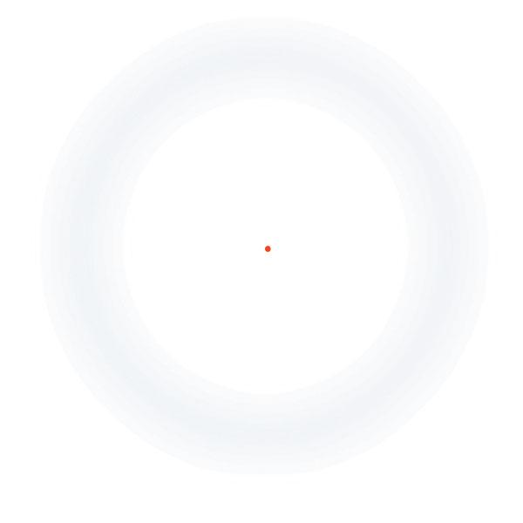

**Figure 1.** An example image of Troxler’s fading.

When focusing on the red dot in the center, the light gray circle around it seems to disappear or change its color to that of the background. In reality, however, the light gray circle is unchanged the whole time and we have just witnessed Troxler’s fading in full effect.

# 2. Idea of the model

Our task is to create a simple model that will explain the phenomenon of Troxler’s fading. In this chapter we will describe the following aspects:

* **Nodes of the model** - all the components that we suggest are related to the process of disappearance of unvarying peripheral stimulus from our perception while we concentrate on the central fixation point
* **Behavior and relations between the model nodes** - what role each component of the model plays in the big picture of the phenomenon. How behavior of one component affects the behavior of others.

## 2.1 Model components

|  |  |  |
| --- | --- | --- |
| **Name** | **Description** | **Behavior** |
| **Node 1** | Retinal cells that become excited in response to the light reflecting from the stimulus and pass this signal to the lateral geniculate nucleus via visual pathways | Retinal cells participate in the process of sensory adaptation that causes a decrease in their sensitivity to the constant stimulus |
| **Node 2** | A pool of neurons in LGN (lateral geniculate nucleus) that is responsible for perceiving peripheral stimuli away from the fixation point | Receives signals from the retinal cells and passes them to the visual cortex. Neurons of this pool participate in the process of neural adaptation that causes a decrease in response to the constant stimulus |
| **Node 3** | A pool of neurons in the visual cortex that is responsible for processing changes in perception of the peripheral stimuli | Neurons of this pool participate in the process of *filling in* the area behind the disappeared stimulus |
| **Node 4** | Pools of retinal cells and pools of neurons in LGN and visual cortex that are responsible for perceiving the central stimulus (fixation point) | Strength of response to the stimulus remains constant during the fixation process |

**Table 1.** Description of model nodes and their behavior

## 

## 2.2 Relation between model nodes

Taking into account the effect of sensory adaptation that occurs on the level of retinal cells, we suggest that the first stage of the fading effect (a decrease in response to the peripheral stimulus) will take place in the model **node 1.** After that the retinal cells will send the remaining signal to the LGN and here the effect of neural adaptation, that will aggravate the effect of fading, will take place (**node 2**). Now LGN will pass the signal through the direct pathway to the primary visual cortex where the visual stimulus will be processed (**node 3**). When the effect of fading has caused a complete disappearance of the stimulus (the strength of the signal coming from LGN is zero) the neurons of the visual cortex will be “confused” because they do not know exactly what to perceive instead of the stimulus that has disappeared. And, since they do not have much choice, in most of the cases, they will decide to perceive the background color in place of the faded stimulus.

During this whole process cells of the model’s **node 4** will constantly respond to the central stimulus (fixation point), because the neurons in the visual system that are responsible for perceiving the small dot in the center have a smaller receptive field and involuntary microsaccades are able to move the stimulus to the new cell’s receptive field thus causing new firing in response to the stimulus.

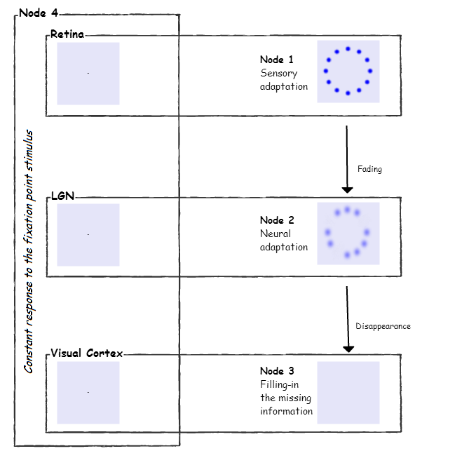

**Figure 2.** Model structure.

# 3. Experiments: Collecting data

It is known that the time of disappearance of the stimulus in the case of the Troxler Effect varies and may depend on many different properties of the stimulus such as its size, blurriness, contrast etc.

Our task is to conduct experiments in order to study and analyze some of the **influencing aspects of the stimulus** - which properties of the stimulus may influence the behavior of the nodes of the model. Which properties have a stronger/weaker influence.

## 3.1 Data structure

We will focus on the following parameters:

* Size
* Blurriness
* Distance from the fixation point

In order to study the influence of a concrete parameter on the length of the period of disappearance, we will fixate the values of all the other parameters except the one that is to be studied. The studied parameter will have 3 different values. After conducting the experiments for each set of parameters we will get the corresponding time that will indicate how long it took for the stimulus to disappear.

|  |  |  |  |  |
| --- | --- | --- | --- | --- |
| **Input: set of parameters** | | | | **Output** |
| **Size** | **Distance from the fixation point** | **Blurriness** | **Color** | **Length of the period of disappearance (ms)** |
| 30 | 160 | 30 | blue | 2500 |
| 30 | 160 | 20 | blue | 5776 |
| 30 | 160 | 10 | blue | 9481 |

**Table 2.** Example of the input and output data

In this case we are studying the influence of blurriness on the length of period of disappearance. As the stimulus becomes less and less blurry - the length of the period increases.

## 3.2 Test environment

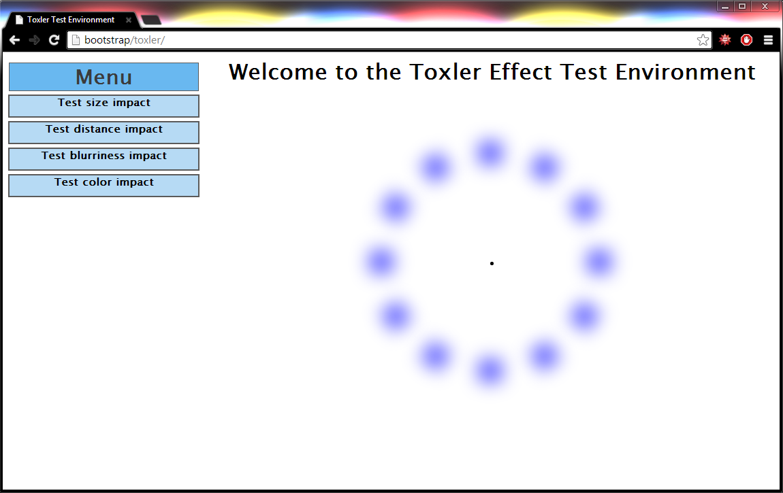

In order to collect data we have developed a test environment where the test subject can measure the length of the period of disappearance of the stimulus from his perception.

First of all, we define concrete sets of parameters as described in the previous chapter. For each set of parameters the test subject is asked to concentrate on the black dot in the center.

In the beginning of the experiment the test subject sets his cursor on the timer’s “Start” button and clicks it. The “Start” button will change **Figure 3.** Test Environment main page

into a “Stop” button so that when the stimulus

disappears completely the test subject will click the same button as before without having to be distracted by moving the mouse somewhere else.

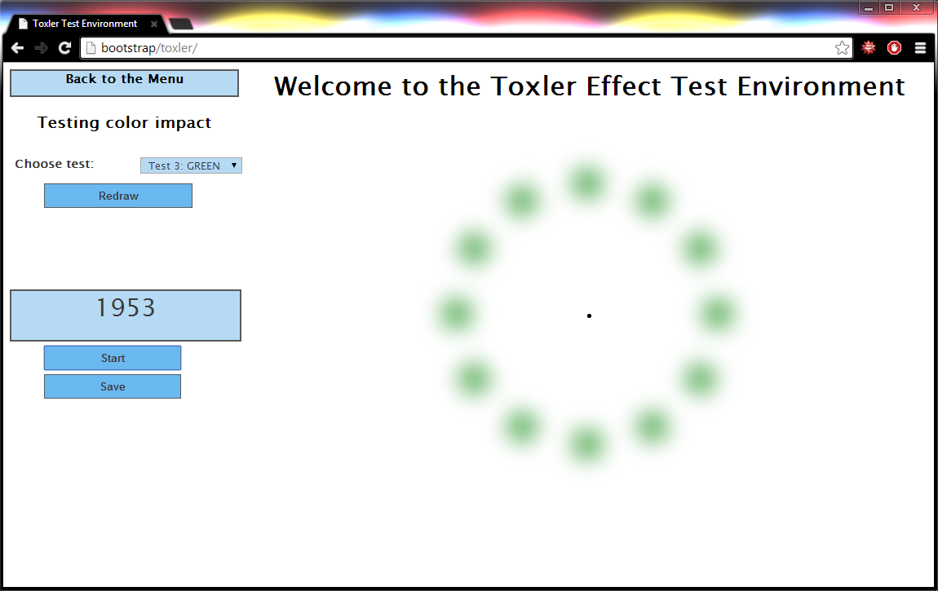

For each new set of parameters, after successful conduction of the experiment, the test subject can press the “Save” button to save the input and output data in order for them to be analyzed.

In this case a **successful conduction of the experiment** is considered to be the process of concentration that has not been interrupted by any factor (blinking, significant eye movements etc.) and has ended with the complete disappearance of the stimulus from the perception.

**Figure 4.** Example of an experiment

After a test subject has successfully conducted all the needed experiments ("Testing size/color/distance/blurriness impact"), as a result, we will obtain 4 files with data about how long did it take for the stimulus with corresponding parameters to disappear from the test subject's perception. Now we can analyze this data and compare it with the results we get from the other test subjects. More about analysis aspects in the next chapter.

# 4. Data analysis

8 test subjects have taken part in the experiments under 3 different conditions for each parameter of our interest. Blurriness and size can be set to 10, 20 or 30 px, distance from the fixation point can be set to 100, 160 or 220 px. The peripheral stimuli will be blurred correspondingly to the chosen value of blurriness, it will have the size of the chosen size value and it will be away from the fixation point correspondingly to the chosen value of distance.

As a result we obtained the following table:

|  |  |  |  |  |  |  |  |  |  |
| --- | --- | --- | --- | --- | --- | --- | --- | --- | --- |
| **Condi-**  **tions**  **Test**  **subjects** | **Parameters** | | | | | | | | |
| **Blurriness (px)** | | | **Size (px)** | | | **Distance (px)** | | |
| 10 | 20 | 30 | 10 | 20 | 30 | 100 | 160 | 220 |
| 1 | 12,875 | 3,635 | 2,022 | 0,709 | 2,154 | 6,100 | 7,868 | 5,910 | 5,186 |
| 2 | 8,136 | 3,598 | 1,720 | 1,509 | 5,432 | 8,276 | 10,770 | 9,512 | 6,123 |
| 3 | 6,329 | 4,835 | 2,430 | 1,163 | 3,987 | 8,213 | 10,689 | 8,654 | 8,926 |
| 4 | 9,735 | 3,016 | 2,828 | 1,400 | 2,389 | 10,890 | 10,389 | 7,380 | 5,859 |
| 5 | 10,006 | 3,706 | 2,138 | 0,983 | 3,064 | 5,975 | 7,534 | 6,582 | 8,979 |
| 6 | 10,264 | 3,832 | 1,395 | 1,634 | 8,902 | 14,679 | 13,636 | 9,479 | 12,130 |
| 7 | 7,293 | 4,830 | 2,038 | 1,239 | 6,293 | 6,004 | 8,540 | 7,293 | 7,023 |
| 8 | 9,488 | 5,649 | 1,753 | 0,865 | 5,812 | 8,284 | 9,421 | 6,316 | 5,117 |
| **Mean (sec):** | **9,266** | **4,138** | **2,041** | **1,188** | **4,754** | **8,553** | **9,856** | **7,641** | **7,418** |

**Table 3.** Results of the experiments and the average time values

## 4.1 Repeated measures ANOVA

In order to determine whether the changes in time values under 3 different conditions are statistically significant, we performed repeated measures ANOVA tests on our data for 3 different parameters.

The source code of the algorithm we used can be found here (link to git)

|  |  |
| --- | --- |
| **Parameter** | **Result** |
| Blurriness | The 3 conditions differ significantly on time values, F(2, 14) = 54.48, p=0.05 |
| Size | The 3 conditions differ significantly on time values, F(2, 14) = 34.59, p=0.05 |
| Distance | The 3 conditions differ significantly on time values, F(2, 14) = 9.1, p=0.05 |

**Table 4.** The result of a repeated-measures analysis of variance

Now that we know the differences in the mean time values under different conditions for the parameters of our interest are really statistically significant in some way, we need to determine where exactly these differences lie. For that we will perform a Post Hoc test that is described in the next chapter.

## 4.2 Post Hoc Tests: Tukey HSD

http://web.mnstate.edu/malonech/images/Repeat401.gifAs a Post Hoc test for our data we choose Tukey Honest Significant Difference test for repeated measures. In this test we use the value of degrees of freedom in the error term (14 in our case), the number of groups (3 groups) and the alpha value (0.05) to look up the “q” statistic in the following table.(link to table)

After the “q” statistic is found, we calculate the HSD value using the following formula.

Here we use the MSerror value that we have previously found with analysis of variance for repeated measures. This value will be different for all the parameters and as a result the HSD value will be different for each parameter of our interest.

When the HSD value is calculated, we take the mean time values for all groups and find out how different they are from each other. If the difference between two group means is greater than the corresponding HSD value, then the difference between them is considered to be statistically significant.

|  |  |
| --- | --- |
| **Parameter** | **Result** |
| Blurriness | Difference between groups 1 and 2 is significant and equal to 5.13(HSD:1.86)  Difference between groups 2 and 3 is significant and equal to 2.1(HSD:1.86)  Difference between groups 1 and 3 is significant and equal to 7.23(HSD:1.86) |
| Size | Difference between groups 1 and 2 is significant and equal to 3.57(HSD:2.32)  Difference between groups 2 and 3 is significant and equal to 3.8(HSD:2.32)  Difference between groups 1 and 3 is significant and equal to 7.36(HSD:2.32) |
| Distance | Difference between groups 1 and 2 is significant and equal to 2.22(HSD:1.91)  Difference between groups 2 and 3 is not significant.  Difference between groups 1 and 3 is significant and equal to 2.44(HSD:1.91) |

**Table 5.** Result of the Tukey HSD test

According to the results we have got, all means of time values of blurriness and size tests differ significantly from each other. As for the distance test, it is considered that there is no statistically significant difference between means of time values under condition 2 (160px away from fixation point) and 3 (220px).

## 4.3 Final Results

After all the statistical tests we have conducted, we can now present the following results:

|  |  |
| --- | --- |
| **Blurriness impact** | |
| C:\Users\Ne Admin\Desktop\BLUR_RESULT.png | Repeated measures ANOVA determined that the mean time value differed significantly between levels of blurriness (F(2, 14) = 54.48, p=0.05).  Post Hoc Tukey HSD test revealed that the difference of mean time values was statistically significant between all the given blurriness levels (10, 20 and 30 px).  The plot on the left shows that the increase in the blurriness level causes significant reduction in time of disappearance of the peripheral stimuli. |
| **Size impact** | |
| C:\Users\Ne Admin\Desktop\SIZE RESULT.png | Repeated measures ANOVA determined that mean time value differed significantly between size values (F(2, 14) = 34.59, p=0.05).  Post Hoc Tukey HSD test revealed that the difference of mean time values was statistically significant between size values (10, 20 and 30 px).  The plot on the left shows that the increase in the size value causes significant increase in time of disappearance of the peripheral stimuli. |
| **Distance impact** | |
| C:\Users\Ne Admin\Desktop\DIST RESULT.png | Repeated measures ANOVA determined that mean time value differed significantly between distance values (F(2, 14) = 9.1, p=0.05).  Post Hoc Tukey HSD test revealed that the difference of mean time values was statistically significant between distance values 100 and 160, 100 and 220. However, a slight reduction in time value between distance values of 160 and 220 was not statistically significant.  The plot on the left shows that the increase in the distance value causes slight reduction in time of disappearance of the peripheral stimuli. |

# 5. Model

First, we will define concepts that are necessary for our model:

* **Experiment** – process that starts with the concentration on the fixation point, followed by disappearance of the peripheral stimuli and then a saccade that causes perception to return back to normal.
* **Response** to the stimuli – we will use abstract level values from 12 to 0. 10-12 being the level of response at which we clearly percept the stimulus, and 0 being the level of response at which stimulus disappears.
* **D** – the moment of disappearance of the peripheral stimuli, depends on the parameters of the stimuli (blurriness, size, distance from the fixation point)
* **Effect** –time difference between **D** time point and the moment when model node response to the stimuli reaches level 0.
* **S** – the moment of the first saccade after stimuli have disappeared, 2 seconds after **D** time point
* **E** – end of the experiment, 0.1 second after **S** time point
* **in** – initial (normal) level of response to the stimulus, equals to 10 in our model
* **m** – level of response that is higher than normal, equals to 12 in our model

In order to define the functions that will illustrate the behavior of the model nodes we need to focus on 3 principal periods:

* **0 < x < D**: Time between beginning of the concentration (time point 0) and D time point
* **D < x < S**: Time between D and S
* **S < x < E**: Time between S and E

Response to the peripheral stimuli for nodes 1, 2 and 3 decreases from level of 10 to 0 during the **0 < x < D** period. It remains zero until the **S** time point. After the **S** time point response will quickly return to its initial value of 10. We will implement the **effect** value of 200 ms and 400 ms on the behavior of the nodes 2 and 3 correspondingly to show the impact of the neural adaptation on the speed of decrease in response to the stimuli. In simple terms, the decrease in response in the retinal cells is caused only by the process of sensory adaptation (effect value will be zero), while for node 2 the decrease in response is aggravated by the process of neural adaptation in the LGN. And for node 4 the decrease in response will be caused by the sum of sensory and neural adaptation, that occur in nodes 1 and 2, and also by the neural adaptation that may occur in the visual cortex.

**Function:**

Response to the background stimulus for node 3 increases from value of 10 to 12 during the **0 < x < D** period, due to the process of *filling in* the area behind the disappeared stimulus. Response level will remain 12 during the **D < x < S** period and after the S time point it will return to its initial value.

**Function:**

**Node 4:** Response to the fixation point stimulus remains constant (10) during the whole time of the experiment.

**Function:**

Noise is a set of random values in range (0, 0.3).

The following plot represents the graphical visualization of the model:

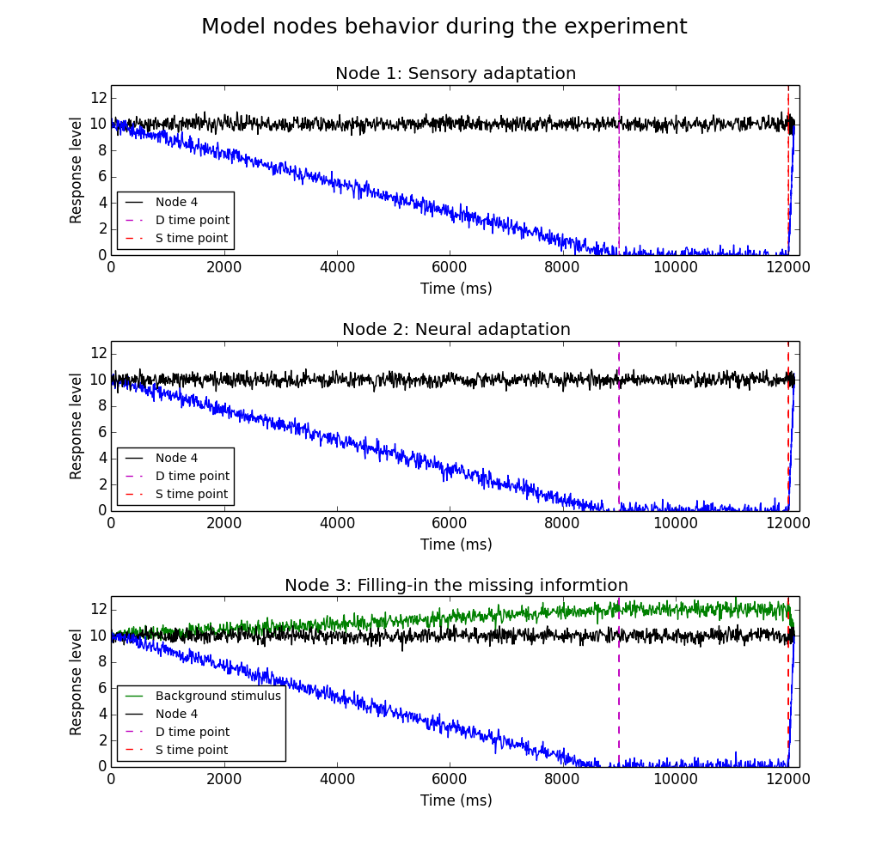

# 6. References

<http://archive.today/iBaGx> (osas 1.1 Origin)

<http://cognet.mit.edu/posters/TUCSON3/Lou.html> (osas 1.2 Concept)

<http://www.trin.cam.ac.uk/horacebarlow/175.pdf__Predict%2BInf%2BHomunc.pdf> (osas 1.2 Concept)